

**Functional Requirements Document**

**ITSR 892800 Callie Clear**

**RPA**

**5/7/2020**

**Revision History**

| **Version** | **Date** | **Author** | **Description** |
| --- | --- | --- | --- |
| 1.0 | 5/18/2020 | Annie To | First Draft |
|  |  |  |  |

**Approvers and Reviewers**

The following individuals have been identified as the reviewers/approvers for this document. Unless otherwise stated, approvals will be stored in the project folder.

| **Name** | **Title** | **Approve** | **Review** |
| --- | --- | --- | --- |
| Kim Burton | UW, Mgr | X |  |
| Kelly Glover | Dir, UW |  | X |
| Kevin Bailey or Nicole Vilchis | Dir, UW R&I, R&I Analyst | X |  |
| Tracy Pratt | UW Sr |  | X |
| Shekhar Kolhatkar | Dir Sr, App Development |  | X |
| Shaguna Virmani | Mgr., Applications Dev |  | X |
| Claudia Casas | UW Admin |  | X |
| Mon-Loe Lee | SW Dev Analyst Principal |  | X |
| Susy Ongko | BSA Sr. |  | X |
| Kruti Patel | Dev Associate |  | X |
| Eva Alvarado | BSA Spvsr |  | X |
| Teja Ellendula | Contractor |  | X |
| Udaya Rayalla | Contractor |  | X |
| Ushabharathi Chittoor | Contractor |  | X |

Table of Contents

1 Overview 3

2 Scope 3

3 Success Criteria 3

4 Assumptions and Constraints 3

5 Functional Requirements 4

5.1 Processing Callie Clear bot 4

5.2 The bot will receive an input file from business. 4

5.4 Login – Guidewire 5

6 Non functional requirements 6

6.1 File location 6

7 Security Considerations 6

8 Application Controls 6

# Overview

This document describes the Robotic Process Automation (RPA) for Callie Clear bot. The bot will clear the activities from the Required Documents page.

# Scope

* The following are in scope for the Callie Clear bot:
  + Clear activities from the Required Documents page.
* Systems:
  + RPA, PC, UI Path
* States
  + NY, CA
* Line of Business
  + LL, HO

# Success Criteria

## UAT Testers

|  |  |
| --- | --- |
| **Name** | **Title** |
| Tracy Pratt | UW Sr |
| Claudia Casas | UW Admin |
| Nicole Vilchis | R&I Analyst |

## UAT Success Criteria

### Test cases will demonstrate that the bot:

#### Bot can successfully clear required documents activities from Required Documents page.

# Assumptions and Constraints

1. Callie Clear bot process will be processed by an unattended bot.
2. This process will not impact the actual applications (PC), the bot is a software that is installed in VDI (virtual machine) and runs scripts to open applications and execute steps as defined in the FRD.
3. Robotic processing is not intended to replace application programming.
4. Robotic processing is not intended to address all possible scenarios.
5. Robotic processing is not intended to replace or program Underwriting decision making.
6. Input file will be dropped daily, bot will check for input file daily.
7. If the input file is not available, bot will email business.
8. If bot is not able to clear the activity, the activity will be left for the agent to work.
9. Business who has access to the input file:

|  |  |
| --- | --- |
| **Business Name(s)** | **Title** |
| Daniel Mancu | UW Analyst |

# Functional Requirements

# Processing Callie Clear bot

# The bot will receive an input file from business.

Below is a sample of the input file



### Bot will look at Column (I) PolicyNumber

### Bot will log into PolicyCenter and process each policy from the PolicyNumber column row by row.

### Bot will navigate to the Required Documents/E-Sign screen and clear all the activities.

#### Bot clears any activity with “Send to Company” under the Action Needed Column.

### Bot will update UW Action column as “Not Needed”

### 

# Note

### After bot has finished clearing the activities from the Required Documents Page, bot will write a note.

#### Bot clicks Quicklinks, then clicks New Note

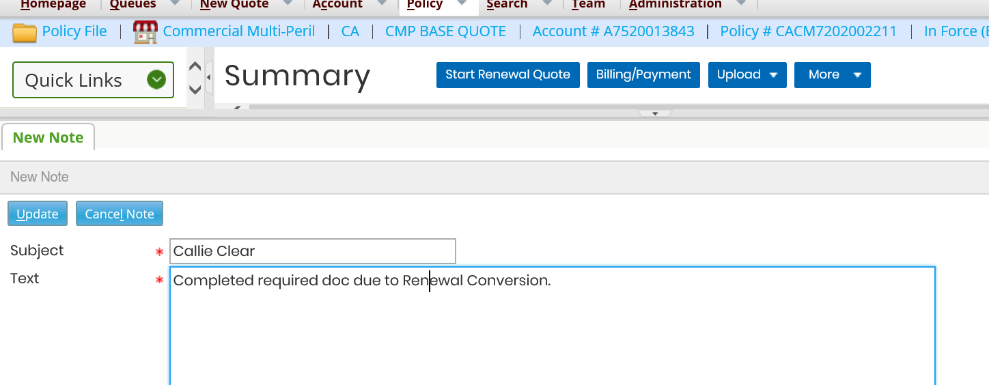

#### New note tab appears, Bot enters the following text:

##### Subject:

###### Callie Clear

##### Text:

###### Completed required doc due to Renewal Conversion.

# Login – Guidewire

### User Name: UW_BPA

### Password: Stored in orchestrator

### Role: Manager

### Browser: Internet Explorer

### URL:

### <https://transcendpc.mercuryinsurance.com/siteminderagent/forms/gw_pc_login.fcc?TYPE=33554433&REALMOID=06-bfd076a3-e015-4bc0-a1f2-b22912899230&GUID=&SMAUTHREASON=0&METHOD=GET&SMAGENTNAME=prd_gwpc_ag&TARGET=-SM-HTTPS%3a%2f%2ftranscendpc%2emercuryinsurance%2ecom%2fpc%2f>

# Reporting

Tracy Pratt and Claudia Casas from business will have access to the report file.

### File location: \\n1brec01a\bpa_data_np\CallieClear\Output

### Columns

#### PolicyNumber

#### SuccessFailure

|  |  |
| --- | --- |
| **PolicyNumber** | **SuccessFailure** |
| XXXXXXXXXXX | Success/Failure |

# Non functional requirements

# File location

### Excel file dropped in network folder.

#### File location: \\n1brec01a\bpa_data_pr\Callie\Input

#### File format: Excel

#### Input File Name: Callie_Clear_Input.csv

#### Users with access to the network folder

|  |  |
| --- | --- |
| Name | Title |
| Daniel Mancu | UW Analyst |

# Security Considerations

Security is not changing as part of this implementation.

# Application Controls

To ensure that all appropriate application controls are included in the Functional Requirements Document, the Business Analyst must complete the Application Controls Table.

**Application Controls Table**

| ACO # | Application Control Objective (ACO) | Financial Statement Assertion | Applicability Explanation  (Yes or No and why) |
| --- | --- | --- | --- |
| ACO-01 | Ensure **adherence to defined business rules** in the flow and accuracy of processing | Accuracy, Completeness, Validity | Yes, section 5 |
| ACO -02 | Ensure that **only authorized transactions** are input and accepted by the application | Validity | Yes, section 5-6 |
| ACO-03 | Ensure that **only accurate data** are input and accepted by the application | Accuracy | Yes, section 5-6 |
| ACO-04 | Ensure that transactions are **processed completely** (no more, no less) **within an application** | Completeness | Yes, section 5-6 |
| ACO-05 | Ensure that transactions are **processed completely** (no more, no less) **between an application and its internal and external interfaces** (both inbound and outbound) | Completeness | Yes, section 5-6 |
| ACO-06 | Ensure that **system generated transactions** and **values** are **accurate and reliable** | Accuracy | Yes, section 5 |
| ACO-07 | Ensure that **system calculations** are **accurate** | Accuracy | No, there are no system calculations performed by bot |
| ACO-08 | Ensure that **errors and exceptions** (e.g., transaction reversals, overrides, error corrections) **are handled properly**, with the appropriate level of authority and audit trail | Validity, Completeness | Yes, section 5 |